Experiment No. 6

Title: Exploring Google Analytics

Batch: B–1 Roll No.: 16010422234 Experiment No.: 6
______________________________________________________________________________

Aim: Exploring Google Analytics.
______________________________________________________________________________

Resources needed: Internet and MS-office

Theory:

GOOGLE ANALYTICS
Knowing your audience and what they want is an important success factor for any website. The best way to know your audience is through your traffic stats and this is exactly what Google Analytics does. Google Analytics is one of the top, most powerful tools out there for monitoring and analysing traffic on your website. It shows:

Who visits your website – user’s geographical location, which browser did they use, what is their screen resolution, which language they speak, etc.

What they do when they are on your website – you can see how long users stay on your website, what pages they are visiting the most, which page is causing the users to leave most often, how many pages an average user is viewing etc.

When they visit your site – you can see which time of the day is the hottest for your website. This helps you pick the time to publish your posts. If that time zone is not compatible, then you can schedule your posts.

Where did they arrive on your website from – you can see how the user found you. Whether it was through a search engine (Google, Bing, Yahoo etc), social networks (facebook, twitter etc), a link from another website, or a direct type-in. Google Analytics also shows you the breakdown of each traffic source, so you can focus on specific ones if you like.

How users interact with your site’s content – You can see how many users clicked on a specific link. In Google Analytics, a small code snippet is included in the web pages of the website. This code snippet enables Google analytics to track websites. During tracking appropriate data is gathered and sent to Google Analytics account.
The Google Analytics Web Tracking method uses the Javascript language as it is compatible code of website. These methods have unique names that do not conflict with the existing Javascript methods of the website.
______________________________________________________________________________

Procedure:
1. Document the statistics provided by Google analytics in each report and mention your inferences.

Results: (Stepwise procedure (with snapshots) for above question)

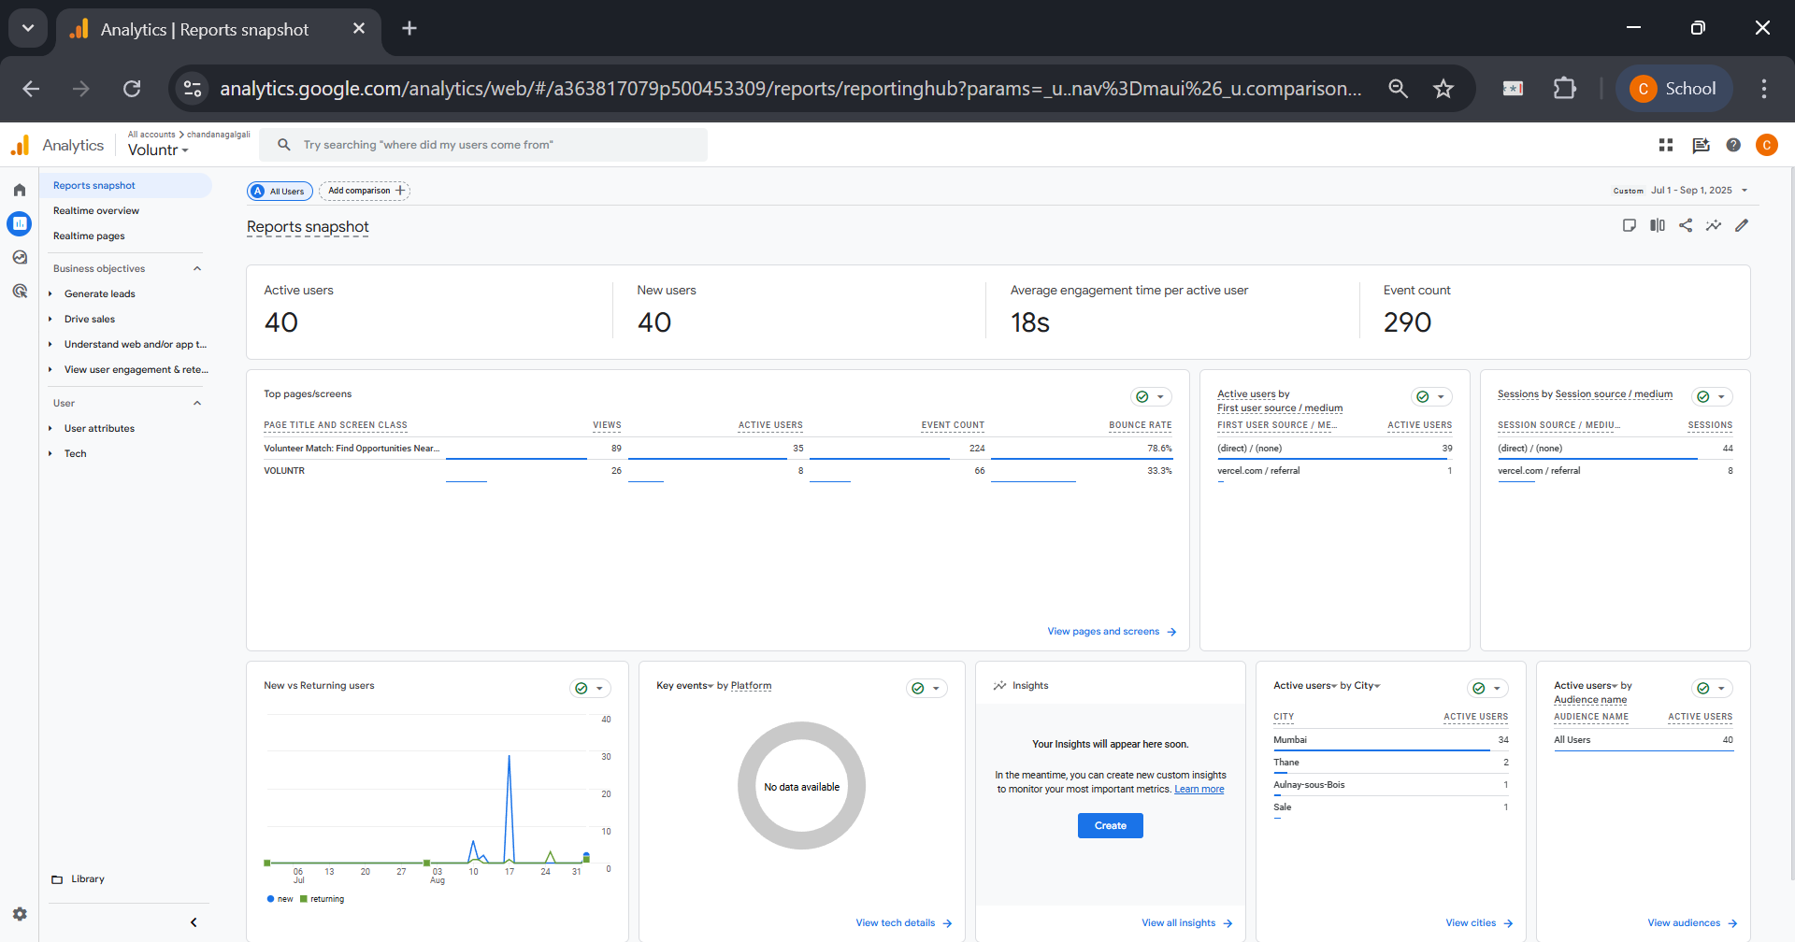

This is the main Reports Snapshot, providing a historical summary of website activity over a two-month period (July 1 to September 1, 2025). This shows trends over time.

- Top-line Metrics:
- Active Users: 40. This is the total number of unique users who visited the site during this two-month period.
- New Users: 40. This is a critical insight. It means that 100% of the users were first-time visitors; there were zero returning visitors.
- Average engagement time: 18s. This is a very low duration, suggesting that, on average, users left the site very quickly without much interaction.
- Event count: 290. This is the total number of actions recorded from all 40 users.

- Data Cards (from left to right, top to bottom):
- Top pages/screens: The most viewed page has a Bounce Rate of 78.6%. A bounce rate is the percentage of single-page sessions in which there was no interaction. A rate this high is concerning, as it means nearly 4 out of 5 visitors left the site after viewing only one page.
- Active users by First user source / medium: This shows that 39 out of 40 users came from (direct) / (none). This means they either typed the URL directly into their browser, used a bookmark, or came from an untracked source. This type of traffic is uncommon for public websites and often points to an internal team.
- New vs Returning users: The line graph clearly shows a few spikes of "New" users (in blue) and a flat line at zero for "Returning" users (in green), visually confirming that all traffic was from first-time visitors.
- Active users by City: The data is heavily skewed towards Mumbai (34 users), with only a few other users from different locations.

Overall Analysis:
This historical report paints a clear picture of a website in a limited, pre-launch, or testing phase. The user base is small, entirely new, and geographically concentrated in Mumbai. The traffic patterns (overwhelmingly "Direct") and user behavior (very low engagement time, high bounce rate, and no returning visitors) are not characteristic of a public-facing website. Instead, they strongly suggest that the 40 "users" are likely a small, internal team or a closed test group accessing the site for brief, specific checks over a two-month period.

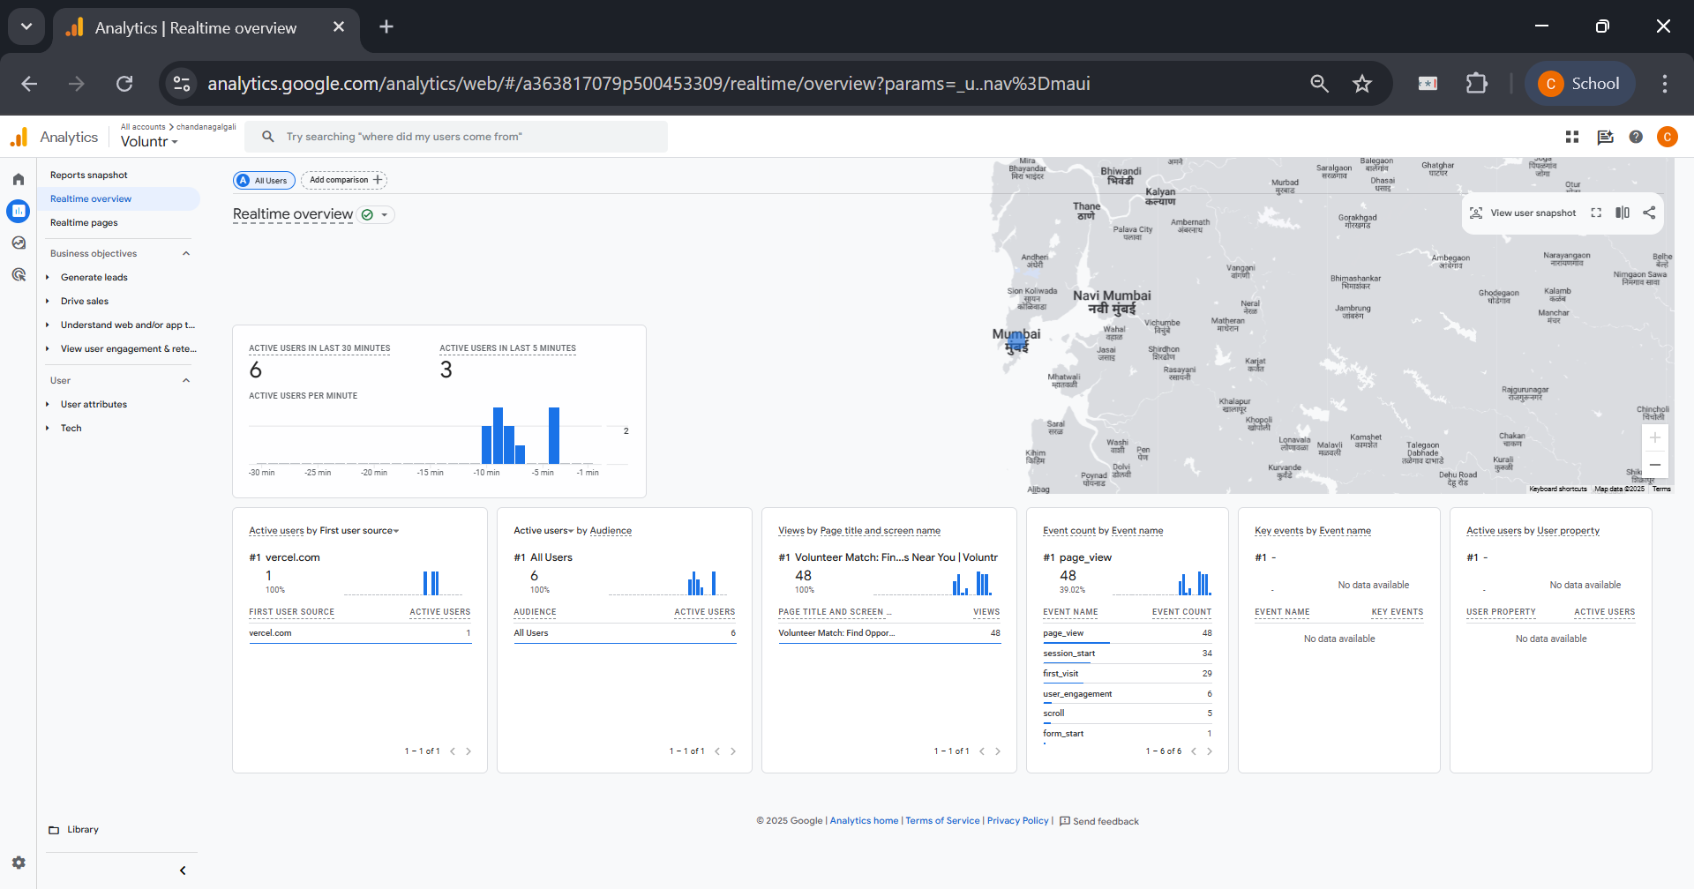

This screenshot displays the Realtime Overview report in Google Analytics. The purpose of this report is to show what is happening on your website right now. It's a live monitor of user activity.

- Main Metrics:
- Active users in last 30 minutes: The number displayed is 6. This means that six distinct users have been active on the website within the last half-hour.
- Active users in last 5 minutes: The number is 3. This is a more immediate metric, showing that three of those six users have been active very recently.
- Active users per minute: The blue bar chart visualizes user activity minute-by-minute over the last 30 minutes, showing small spikes of 1-2 users at a time.

- Geographic Map:
- The map of the world prominently features a blue circle over Mumbai, India. This visually indicates the geographical location of the currently active users.

- Data Cards (from left to right):
- Active users by First user source: This card shows how the current users initially found the website. It lists vercel.com as a source for 1 user. Vercel is a popular platform for hosting and deploying web applications, so this source strongly suggests the user clicked a link from a development or preview environment.
- Active users by Audience: This card shows that 100% of the 6 active users belong to the "All Users" audience.
- Views by Page title and screen name: This card lists the most popular pages among the current active users. The top page is "Volunteer Match Find..." with 48 views, indicating it is the main point of interaction.
- Event count by Event name: This shows the actions (events) users are taking. The top event is page_view with 48 counts, followed by first_visit, user_engagement, scroll, and form_start. This means users are not just landing but also scrolling and beginning to interact with forms.
- Key events by Event name and Active users by User property: These cards show "No data available," meaning no specific conversion events or custom user properties have been triggered by the current users.

Overall Analysis:
This report provides a snapshot of a small, live testing session. The traffic is highly localized to Mumbai and appears to be internal or developer-driven, as indicated by the vercel.com referral source. The users are actively viewing pages and beginning to interact with forms, suggesting they are testing the site's core functionalities.

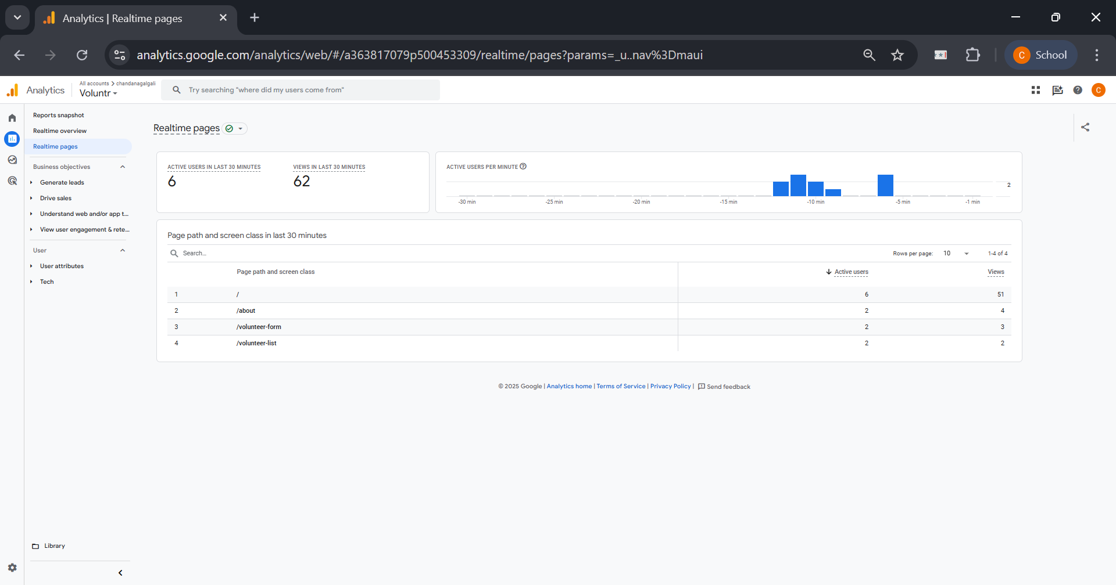

This screenshot shows the Realtime Pages report. It is a more detailed view within the Realtime section that focuses specifically on which pages are being viewed by active users.

- Header Metrics:
- Active users in last 30 minutes: 6. This is consistent with the Realtime Overview.
- Views in last 30 minutes: 62. This indicates that the 6 active users have collectively generated 62 page views in the last half-hour, meaning they are navigating between multiple pages.

- Page path and screen class Table:
- This table is the core of the report, listing the specific page paths and the number of active users currently viewing them.
- Row 1 (/): The homepage or root path has 6 active users. This means all currently active users are on the homepage.
- Row 2 (/about): The "About" page has 2 active users.
- Row 3 (/volunteer-form): The form for volunteering has 2 active users.
- Row 4 (/volunteer-list): The list of volunteer opportunities has 2 active users.
- (Note: The user numbers add up to more than 6 because one user can be active on multiple pages or be counted as they navigate between them).

Overall Analysis:
This report confirms that the live users are highly engaged. They are not just landing on the homepage and leaving. Instead, they are exploring the entire user journey: learning about the organization (/about), viewing opportunities (/volunteer-list), and starting the sign-up process (/volunteer-form). This pattern of behavior is typical of someone thoroughly testing the website's functionality from start to finish.
______________________________________________________________________________

Questions:

- Write note on: Diagnosing Conversion rate trouble.

Ans: Diagnosing trouble with a website's conversion rate—the percentage of visitors who complete a desired goal (like a purchase or sign-up)—is a critical process for improving performance. It involves moving from identifying the symptom (a low conversion rate) to finding the root cause. This diagnosis is a multi-step process combining quantitative data analysis with qualitative user experience evaluation.

i) Establish a Baseline and Identify the Drop-off Point:
The first step is to use a tool like Google Analytics to understand the user journey. By setting up Goal Funnels, we can visualize the steps a user takes to convert. This immediately shows where the largest percentage of users are dropping off. For an e-commerce site, the funnel might be: View Product > Add to Cart > Proceed to Checkout > Enter Shipping > Payment > Purchase Confirmation. A high drop-off rate between "Add to Cart" and "Proceed to Checkout" pinpoints the exact area of trouble.

ii) Segment the Data to Isolate the Problem:
A low overall conversion rate might be caused by a specific segment of your audience. The problem should be diagnosed by segmenting data based on:
- Traffic Source: Are users from social media converting less than users from organic search? This could indicate a mismatch between ad copy and landing page content.
- Device Type: Is the conversion rate significantly lower on mobile devices? This strongly suggests issues with mobile responsiveness, page speed on mobile, or a difficult mobile checkout process.
- User Demographics: Are users from a specific country or region failing to convert? This could be due to language barriers, currency issues, or unsupported payment methods.
- New vs. Returning Visitors: If new visitors aren't converting, it might be a trust or clarity issue on the landing page.

iii) Conduct a Qualitative UX/UI Audit:
Once you know where the problem is, you need to figure out why. This requires a qualitative look at the problematic pages:
- Clarity and Call-to-Action (CTA): Is the primary action you want the user to take obvious? Is the CTA button prominent, with clear, compelling text?
- Trust and Credibility: Does the page have trust signals like security badges (for payments), customer reviews, or clear contact information?
- Friction and Distractions: Are there unnecessary form fields, pop-ups, or confusing navigation elements that distract the user from the goal?
- Technical Errors: Check for broken links, slow-loading pages, or scripts that fail to execute on certain browsers.

iv) Gather Direct User Feedback:
The best way to understand user struggles is to ask them.
- Heatmaps and Session Recordings: Tools like Hotjar or Crazy Egg show where users are clicking, how far they scroll, and can provide recordings of anonymous user sessions. This can reveal if users are clicking on non-clickable elements or ignoring the CTA.
- A/B Testing: Once a potential problem is identified (e.g., a confusing headline), create a variation (Version B) and test it against the original (Version A). By showing each version to 50% of your audience, you can get definitive data on which one performs better.

By systematically combining quantitative data from Google Analytics with qualitative insights from UX audits and user feedback, one can accurately diagnose and fix the issues causing a low conversion rate.
______________________________________________________________________________

Outcomes: CO3 – Prepare web site for web marketing and understanding SEO analytics
______________________________________________________________________________

Conclusion: (Conclusion to be based on the objectives and outcomes achieved)
This experiment was conducted to explore the fundamental reports and capabilities of Google Analytics. Through the documentation of various statistics, it was determined that Google Analytics is an essential tool for understanding website performance and user behavior. The exploration successfully met its objective by demonstrating how the platform provides detailed insights into who the audience is (demographics, location), what they do on the site (page views, session duration), where they come from (traffic sources), and how they interact with content. The outcome of this experiment is a clear understanding of how to leverage these analytics to make informed, data-driven decisions for optimizing a website's content, user experience, and overall marketing strategy.

______________________________________________________________________________
Grade: AA / AB / BB / BC / CC / CD / DD

Signature of faculty in-charge with date
______________________________________________________________________________

References:
1. Eric Enge, Stephan Spencer, Jessie Stricchiola, Rand Fishkin, “The Art of SEO, Mastering Search Engine Optimization”, O'Reilly Media; 2nd edition, 2012
2. John I Jerkovic, “SEO Warriors”, O'Reilly Media; 1st edition, 2009
3. RafiqElmansy, “Teach Yourself VISUALLY Search Engine Optimization (SEO)” John Wiley & Sons, 2013
______________________________________________________________________________

